**Name :** Yadav Vishal Tahsildar

**Roll no :** 69

**Batch :** I6

**Class :** TEIT 2

**Sub :** IP Lab

**Date :** 29 Aug 2022

**Experiment no : 04**

**Aim :** Java Script class and inheritance

**Theory :**

**Class :**

Classes are a template for creating objects. They encapsulate data with code to work on that data. Classes in JS are built on prototypes but also have some syntax and semantics that are not shared with ES5 class-like semantics.

**Example :**

One way to define a class is using a class declaration. To declare a class, you use the class keyword with the name of the class ("Rectangle" here).

class Rectangle {

constructor(height, width) {

this.height = height;

this.width = width;

}

}

**Class Inheritance**

To create a class inheritance, use the extends keyword.

A class created with a class inheritance inherits all the methods from another class:

Inheritance is useful for code reusability: reuse properties and methods of an existing class when you create a new class.

**Example :**

<script>

let animal = {

animalEats: true,

};

let rabbit = {

rabbitJumps: true,

};

// Sets rabbit.[[Prototype]] = animal

rabbit.__proto__ = animal;

console.log(rabbit.animalEats);

console.log(rabbit.rabbitJumps);

</script>

**Code :**

<!DOCTYPE html>

<html>

<body>

<h2>JavaScript Class Inheritance</h2>

<p id="demo"></p>

<script>

class Book {

  constructor(brand) {

    this.bookname = brand;

  }

  present() {

    return 'I have a ' + this.bookname;

  }

}

class Model extends Book {

  constructor(brand, mod) {

    super(brand);

    this.model = mod;

  }

  show() {

    return this.present() + ', it is a ' + this.model;

  }

}

let myBook = new Model("The Star", "Book");

document.getElementById("demo").innerHTML = myBook.show();

</script>

</body>

</html>

**Output :**

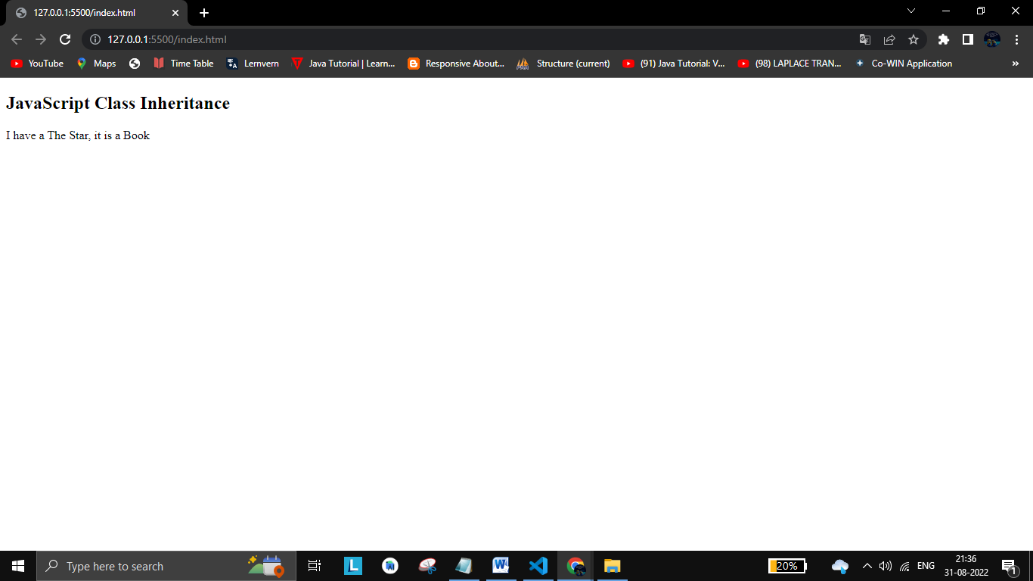

**Conclusion :** Therefore we have successfully implemented Class and Inheritance in javascript.